Graph on the Coordinate Plane — Homework
Lesson 9-1-flagship • Standard 6.NOS.6
Name: ______________________ Period: ______ Date: ____________

Today's Goals
Content: I can plot and identify points on the coordinate plane using ordered pairs.
Language: I can explain my work using the words coordinate plane, ordered pair, origin, and quadrant.

Key Words
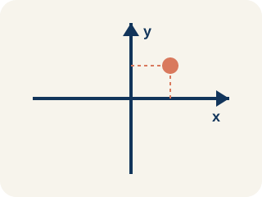
Coordinate plane (Plano cartesiano) — A grid with a line going across and a line going up that cross.
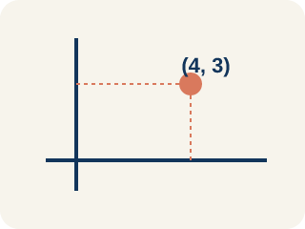
Ordered pair (Par ordenado) — Two numbers (x, y) that tell where a point is on a grid.
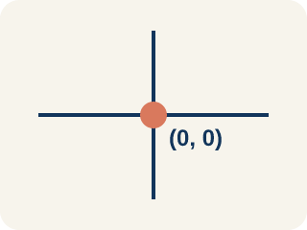
Origin (Origen) — The point (0, 0) where the two grid lines cross.
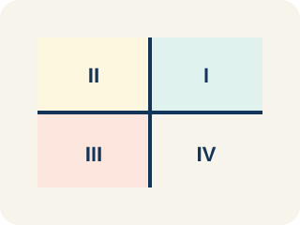
Quadrant (Cuadrante) — One of the four parts of a coordinate grid.
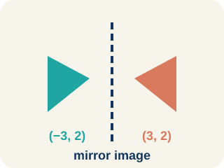
Reflection (Reflexión) — A flipped, mirror image across a line.
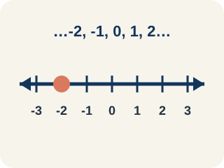
Integer (Número entero) — Whole numbers and their opposites, like -2, -1, 0, 1, 2.

Practice
Show your work. Use the blank space under each problem.
1. Which ordered pair names a point 3 units right and 7 units up from the origin?
A. (3, 7)
B. (7, 3)
C. (3, 3)
D. (0, 7)
______________________________________________________________________
2. What are the coordinates of the origin?
A. (0, 0)
B. (1, 1)
C. (0, 1)
D. (1, 0)
______________________________________________________________________
3. Match each point to its quadrant or axis.
Item | Answer choices
____ (3, 2) | F. x-axis
____ (-4, 5) | E. y-axis
____ (-2, -6) | D. Quadrant IV
____ (7, -1) | C. Quadrant III
____ (0, 3) | B. Quadrant II
____ (5, 0) | A. Quadrant I
______________________________________________________________________
4. Complete the table. Write the ordered pair for each description.
Description | Ordered Pair
Right 7, Up 2
Right 0, Up 5
Right 4, Up 0
Right 3, Up 3
______________________________________________________________________
5. Sort each item into the correct group.
• undefined → __________________
• undefined → __________________
• undefined → __________________
• undefined → __________________
• undefined → __________________
______________________________________________________________________
6. onLevel — Spot the Common Mistake
Step 1 (Ordered pair): Name the quadrant of the point (-2, 6).
Step 2 (Read the signs): x = -2 (negative), y = 6 (positive).
Step 3 (Name the quadrant): Negative numbers are at the bottom, so the point is in Quadrant III.
Which step has the mistake? Explain and fix it:
______________________________________________________________________
______________________________________________________________________
______________________________________________________________________
7. Stage 1 — Captain Vega's note says the first landmark, Palm Cove, is 6 units to the right and 4 units up from the origin. Which ordered pair names Palm Cove?
A. (6, 4)
B. (4, 6)
C. (6, 0)
D. (0, 4)
______________________________________________________________________
8. Stage 2 — The next clue points to Skull Rock at (-5, 3). Which quadrant is Skull Rock in?
A. Quadrant II
B. Quadrant I
C. Quadrant III
D. Quadrant IV
______________________________________________________________________
9. Stage 3 — Sort each treasure landmark into the correct quadrant based on its ordered pair (x, y).
Groups: Quadrant I (+x, +y) | Quadrant II (-x, +y) | Quadrant III (-x, -y) | Quadrant IV (+x, -y)
• Palm Cove (3, 2) → __________________
• Skull Rock (-4, 1) → __________________
• Sunken Ship (-2, -5) → __________________
• Coral Reef (6, -3) → __________________
• Lighthouse (5, 7) → __________________
• Shipwreck Bay (-6, -2) → __________________
______________________________________________________________________
10. Stage 4 — Match each landmark on the map to its ordered pair.
Item | Answer choices
____ Treasure Chest | F. (0, 6)
____ Pirate Cave | E. (4, 0)
____ Anchor Point | D. (8, -1)
____ Mermaid Lagoon | C. (-2, -4)
____ Dock | B. (-3, 6)
____ Watchtower | A. (7, 5)
______________________________________________________________________

Answer Key (Teacher)
1. A. (3, 7)
The first coordinate is horizontal (right 3), the second is vertical (up 7). So (3, 7).
Watch for: A common mistake in Graph on the Coordinate Plane is swapping the x- and y-coordinates when plotting a point — moving up first using the y-value, then moving right using the x-value, instead of always reading the ordered pair as (horizontal, vertical). For the point (3, 5), this mistake lands the dot at (5, 3) instead of the correct spot: right 3, then up 5. Before you submit, retrace your steps and check that you moved right/left using the FIRST number and up/down using the SECOND number.
2. A. (0, 0)
The origin is where the x-axis and y-axis cross, at (0, 0).
Watch for: A common mistake in Graph on the Coordinate Plane is swapping the x- and y-coordinates when plotting a point — moving up first using the y-value, then moving right using the x-value, instead of always reading the ordered pair as (horizontal, vertical). For the point (3, 5), this mistake lands the dot at (5, 3) instead of the correct spot: right 3, then up 5. Before you submit, retrace your steps and check that you moved right/left using the FIRST number and up/down using the SECOND number.
3. Matches:
(3, 2) → Quadrant I
(-4, 5) → Quadrant II
(-2, -6) → Quadrant III
(7, -1) → Quadrant IV
(0, 3) → y-axis
(5, 0) → x-axis

4. Complete the table. Write the ordered pair for each description.
Right 7, Up 2 — Ordered Pair: (7, 2)
Right 0, Up 5 — Ordered Pair: (0, 5)
Right 4, Up 0 — Ordered Pair: (4, 0)
Right 3, Up 3 — Ordered Pair: (3, 3)

5. Correct groups:
undefined → undefined
undefined → undefined
undefined → undefined
undefined → undefined
undefined → undefined

6. onLevel — Spot the Common Mistake
The mistake is in Step 3.
Correct work: A negative x and a positive y land in the top-left region, which is Quadrant II — not Quadrant III. Quadrant III is where BOTH coordinates are negative (-x, -y).
7. A. (6, 4)
The first number is horizontal (right 6) and the second is vertical (up 4), so Palm Cove is at (6, 4).
Watch for: A common mistake in Graph on the Coordinate Plane is swapping the x- and y-coordinates when plotting a point — moving up first using the y-value, then moving right using the x-value, instead of always reading the ordered pair as (horizontal, vertical). For the point (3, 5), this mistake lands the dot at (5, 3) instead of the correct spot: right 3, then up 5. Before you submit, retrace your steps and check that you moved right/left using the FIRST number and up/down using the SECOND number.
8. A. Quadrant II
The x-coordinate is negative (left) and the y-coordinate is positive (up). Negative x and positive y land in the top-left region, Quadrant II.
Watch for: A common mistake in Graph on the Coordinate Plane is swapping the x- and y-coordinates when plotting a point — moving up first using the y-value, then moving right using the x-value, instead of always reading the ordered pair as (horizontal, vertical). For the point (3, 5), this mistake lands the dot at (5, 3) instead of the correct spot: right 3, then up 5. Before you submit, retrace your steps and check that you moved right/left using the FIRST number and up/down using the SECOND number.
9. Correct groups:
Palm Cove (3, 2) → Quadrant I (+x, +y)
Skull Rock (-4, 1) → Quadrant II (-x, +y)
Sunken Ship (-2, -5) → Quadrant III (-x, -y)
Coral Reef (6, -3) → Quadrant IV (+x, -y)
Lighthouse (5, 7) → Quadrant I (+x, +y)
Shipwreck Bay (-6, -2) → Quadrant III (-x, -y)

10. Matches:
Treasure Chest → (7, 5)
Pirate Cave → (-3, 6)
Anchor Point → (-2, -4)
Mermaid Lagoon → (8, -1)
Dock → (4, 0)
Watchtower → (0, 6)

