UNIT 8 · LESSON 2 STANDARD 6.DS.4

Mean, Median, and Mode
Student Notes Packet
Name: ______________________ Date: ____________ Period: ________

Today's Goals
Content: I can find the mean, median, and mode of a data set.
Language: I can explain my reasoning using the words mean, median, mode, and outlier.

Key Vocabulary
Look at the picture, read the word, then read what it means.
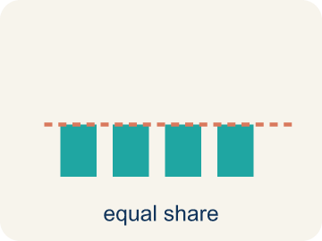 | Mean Media  The average. Add all the numbers, then divide by how many there are.  Example: Mean of 2, 4, 6: add them (2+4+6=12), divide by 3 → mean = 4
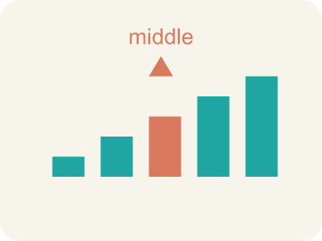 | Median Mediana  The middle number when you put them in order.  Example: Data: 1, 3, 5, 7, 9 → the middle (3rd) value is 5, so median = 5
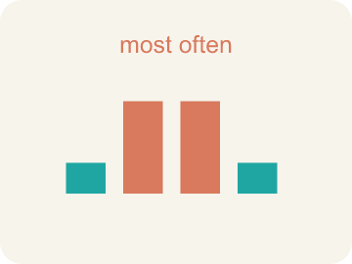 | Mode Moda  The number that shows up most often.  Example: Data: 2, 3, 3, 5, 7 → 3 appears twice (most often), so mode = 3
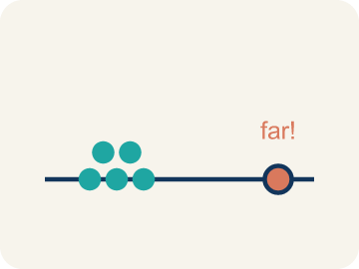 | Outlier Valor atípico  A number that is much bigger or smaller than the rest.  Example: Data: 10, 12, 11, 13, 50 → 50 is far from the others, so 50 is an outlier
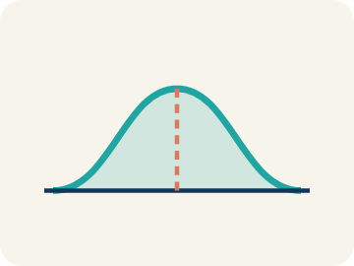 | Data distribution Distribución de datos  How the data looks: where it sits and how spread out it is.  Example: If most values cluster in the center with fewer at the ends, the distribution is symmetric
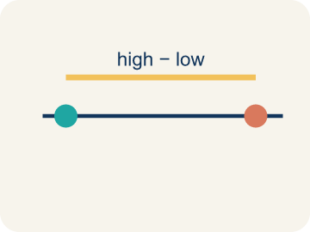 | Variability Variabilidad  How spread out the numbers are.  Example: 8, 9, 10, 11 has low variability (close together); 2, 10, 25, 40 has high variability (far apart)

Guided Notes
Fill in each blank as we go. Use the Word Bank to help you.
WORD BANK
Mean • Median • Mode • Outlier • Data distribution • Variability

1. The average found by adding all values and dividing by how many there are is the ___.
2. The middle value of a data set when the numbers are in order is the ___.
3. The value that appears most often in a data set is the ___.
4. A value that is much larger or smaller than the rest of the data is an ___.
5. The way data values are spread out is the ___.
6. How spread out the data values are is the ___.

Write About the Math
Use the support level you need. Every level answers the same math question.

1. Understand the Question compare
After ordering the scores on the number line, how do you find the median, and how is it different from the mean you calculated?
Your job: Answer the question. Use math evidence. Explain how the evidence proves your answer.
Responde la pregunta. Usa evidencia matemática. Explica cómo la evidencia demuestra tu respuesta.

2. Plan Your Math Words check at least two
☐ Mean — The average. Add all the numbers, then divide by how many there are.
Media — El promedio. Suma todos los números y divide entre cuántos hay.
☐ Median — The middle number when you put them in order.
Mediana — El número del medio cuando los pones en orden.
☐ Mode — The number that shows up most often.
Moda — El número que aparece más veces.
☐ Outlier — A number that is much bigger or smaller than the rest.
Valor atípico — Un número mucho mayor o menor que los demás.
☐ Data distribution — How the data looks: where it sits and how spread out it is.
Distribución de datos — Cómo se ven los datos: dónde están y qué tan separados están.
Say it first: Say your idea to a partner or quietly to yourself before you write.
To find the median, I first ___ the scores, then pick the ___.
Para hallar la mediana, primero ___ los puntajes y luego elijo el ___.

3. Build Your Explanation choose your support
This model shows the parts of an explanation. It does not answer your writing question.
Claim: Mean, median, and mode each describe the center of the data in a different way.
Evidence: Students distinguish the three measures and justify a choice, noting the mode (38) is the most repeated and the mean/median sit near the center.
Reasoning: This evidence connects the definition of mean to the mathematical claim.

Start Most language support
Complete the frames. Use the word bank.
Completa las oraciones. Usa el banco de palabras.
To find the median, I first ___ the scores, then pick the ___.
Para hallar la mediana, primero ___ los puntajes y luego elijo el ___.
The mean is different because I have to ___ and ___.
La media es diferente porque tengo que ___ y ___.

Build Some language support
Write two connected sentences. Use because, so, or but.
Escribe dos oraciones conectadas. Usa porque, entonces o pero.
My claim is ___.
Mi afirmación es ___.
I know because ___.
Lo sé porque ___.
So ___.
Entonces ___.

Explain Light language support
Write a claim, give math evidence, and explain your reasoning.
Escribe una afirmación, da evidencia matemática y explica tu razonamiento.
My claim is ___.
Mi afirmación es ___.
My math evidence is ___.
Mi evidencia matemática es ___.
This proves ___ because ___.
Esto demuestra ___ porque ___.

4. Check Your Explanation five quick checks
☐ I answered the question.
Respondí la pregunta.
☐ I used math evidence: numbers, an equation, a model, or a comparison.
Usé evidencia matemática: números, una ecuación, un modelo o una comparación.
☐ I explained how the evidence proves my answer.
Expliqué cómo la evidencia demuestra mi respuesta.
☐ I used at least two math words.
Usé por lo menos dos palabras matemáticas.
☐ I reread complete sentences and punctuation.
Volví a leer mis oraciones completas y la puntuación.

Worked Example

Watch & Read I Do — follow along with your teacher
Game Day Stats
You're the stats analyst for the school basketball team. Coach needs a report on the team's scoring: in the last 7 games they scored 42, 38, 55, 41, 38, 44, and 40 points. Which average best represents the team's typical performance?

Think about:
• What are the highest and lowest scores?
• Do any scores repeat?
• Which score seems like a typical game for this team?
• Will the mean and median be the same number?
• How does the 55-point game affect the average?

Solved Example I Do — watch each step
Problem: Find the mean of: 10, 14, 8, 12, 16
A) 12
B) 14
C) 10
D) 60
Step 1: Sum = 10 + 14 + 8 + 12 + 16 = 60.
Step 2: Mean = 60 ÷ 5 = 12.
Answer: A. 12

Guided Practice

Solve Together We Do — work with your class
Problem: Find the median of: 3, 7, 2, 9, 5
A) 5
B) 3
C) 7
D) 5.2
Step 1:

Step 2:

Answer:

Your class took a math quiz. The scores were: 85, 92, 78, 88, 92, 95, 72, 88, 92, 84. The teacher says 'most students scored around 87.' A student disagrees and says 'the most common score was 92.'
Who is using the mean, and who is using the mode? Which is more useful here?

Sentence frame: The teacher used the ___ (about 86.6). The student used the ___ (92). The ___ is more useful here because ___.

Turn & Talk discuss with a partner
1. [Launch] The team scored 42, 38, 55, 41, 38, 44, 40 points over 7 games. Which 'average' would best tell the coach the team's typical scoring: mean, median, or mode?
Start with: I would use the ___ because it best shows the typical score.
Usaría la ___ porque muestra mejor el puntaje típico.
Word bank: mean, median, mode, average, data set
2. [Explore] After ordering the scores on the number line, how do you find the median, and how is it different from the mean you calculated?
Start with: To find the median, I first ___ the scores, then pick the ___.
Para hallar la mediana, primero ___ los puntajes y luego elijo el ___.
Word bank: mean, median, mode, order, data set
3. [Connect] Quiz scores were 85, 92, 78, 88, 92, 95, 72, 88, 92, 84. The teacher says 'most scored around 87'; a student says 'the most common score was 92.' Who used the mean, and who used the mode?
Start with: The teacher used the ___, and the student used the ___.
El maestro usó la ___, y el estudiante usó la ___.
Word bank: mean, median, mode, average, data set
4. [Reflect] For the data set 4, 7, 10, 7, 12, talk through how you find the median.
Start with: First I order the values: ___.
Primero ordeno los valores: ___.
Word bank: median, mean, mode, order, middle
5. [Practice] During practice on Mean, Median, and Mode, what strategy did you use when a problem felt tricky?
Start with: To find the median, I first ___ the scores, then pick the ___.
Para hallar la mediana, primero ___ los puntajes y luego elijo el ___.
Word bank: Mean, Median, Mode, Outlier

Independent Practice

On Your Own You Do — show your work
Solve each problem. Show your thinking in the work box.

Level 1 Support extra scaffolding
1. Find the mode of: 4, 7, 4, 9, 2, 4, 8
A) 4
B) 7
C) 9
D) 2

2. Find the mean of: 6, 8, 10, 12, 14
A) 10
B) 8
C) 12
D) 50

On Level grade-level practice
3. Data set: 4, 6, 6, 8, 10, 12. What is the median?
A) 7
B) 6
C) 8
D) 7.67

Exit Ticket
Answer on your own. This shows what you learned today.
★ Data set: 4, 7, 10, 7, 12. What is the median?
A) 7
B) 8
C) 10
D) 4

