Write Equations — Homework
Lesson 7-1 • Standard 6.AT.8
Name: ______________________ Period: ______ Date: ____________

Today's Goals
Content: I can write an equation to represent a real-world situation.
Language: I can explain my equation using the words equation, variable, equal sign, and expression.

Key Words
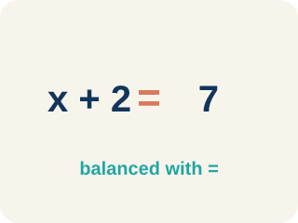
Equation (Ecuación) — A math sentence with an equal sign showing both sides are the same.
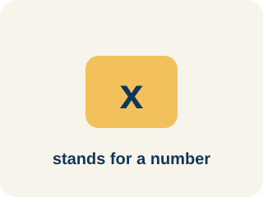
Variable (Variable) — A letter that stands for an unknown number.
Equal sign (Signo igual) — The = sign, showing both sides are the same.
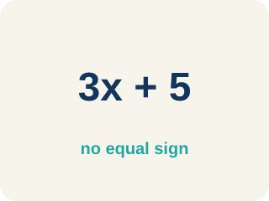
Expression (Expresión) — A math phrase with numbers and letters, but no equal sign.
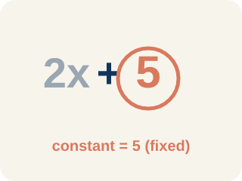
Constant (Constante) — A fixed number in an expression or equation that does not change.
Unknown (Incógnita) — The value you are trying to find, usually shown with a variable.

Practice
Show your work. Use the blank space under each problem.
1. Which equation represents: 'A number plus 12 equals 30'?
A. n + 12 = 30
B. n − 12 = 30
C. 12n = 30
D. n / 12 = 30
______________________________________________________________________
2. Which equation represents: 'Seven less than a number is 18'?
A. n − 7 = 18
B. 7 − n = 18
C. n + 7 = 18
D. n / 7 = 18
______________________________________________________________________
3. For each situation, identify what the variable represents and write the equation.
Situation | Variable Represents | Equation
A box holds some files. After removing 5, there are 13 left. | Number of files in the box | n − 5 = 13
A detective split 48 photos equally into folders. Each folder has 6 photos. | Number of folders | 48 / n = 6
______________________________________________________________________
4. A detective found some fingerprints on Monday and 14 more on Tuesday, for a total of 30. Which equation represents this?
A. f + 14 = 30
B. f − 14 = 30
C. 14f = 30
D. f / 14 = 30
______________________________________________________________________
5. Crack the Equation Error
Step 1 (Clue): A number of case files divided by 3 equals 6.
Step 2 (Choose a variable): Let n be the number of case files.
Step 3 (Write the equation): 3n = 6
Which step has the mistake? Explain and fix it:
______________________________________________________________________
______________________________________________________________________
______________________________________________________________________
6. A witness statement reads: 'A number c of security cameras plus 6 more equals 19.' Which equation matches?
A. c + 6 = 19
B. 6c = 19
C. c − 6 = 19
D. c / 6 = 19
______________________________________________________________________
7. The lab tech says: '5 times the number of evidence bags b equals 35.' Which equation represents this clue?
A. 5b = 35
B. b + 5 = 35
C. b − 5 = 35
D. b / 5 = 35
______________________________________________________________________
8. A torn note reads: 'A suspect's case minutes m, after 9 fewer, leaves 24.' Which equation fits?
A. m − 9 = 24
B. m + 9 = 24
C. 9m = 24
D. m / 9 = 24
______________________________________________________________________
9. Match each detective clue to the equation that cracks it.
Item | Answer choices
____ A number d of door codes plus 4 equals 17. | D. s / 5 = 8
____ 6 times the number of tips t equals 42. | C. f − 11 = 20
____ A pile of files f, after losing 11, equals 20. | B. 6t = 42
____ A number of suspects s split into 5 vans equals 8 per van. | A. d + 4 = 17
______________________________________________________________________
10. Drag each clue phrase into the operation a detective should write.
Groups: Addition (+) | Subtraction (−) | Multiplication (×) | Division (÷)
• increased by 7 → __________________
• sum of clues → __________________
• 13 fewer than → __________________
• decreased by 8 → __________________
• triple the tips → __________________
• split equally among → __________________
______________________________________________________________________

Answer Key (Teacher)
1. A. n + 12 = 30
'Plus' means addition, so the equation is n + 12 = 30.
Watch for: A common mistake in Write Equations is writing subtraction and division clues in the wrong order — putting the number from the clue first instead of the variable first. For 'a number decreased by 8 equals 5,' students often write 8 − n = 5 instead of the correct n − 8 = 5; for 'a number divided by 4 equals 6,' they write 4 ÷ n (or 4n) instead of n / 4 = 6. Always start with the variable, then attach the operation in the order the words describe it, and check by substituting your answer back in.
2. A. n − 7 = 18
'Seven less than a number' means start with the number and subtract 7: n − 7 = 18.
Watch for: A common mistake in Write Equations is writing subtraction and division clues in the wrong order — putting the number from the clue first instead of the variable first. For 'a number decreased by 8 equals 5,' students often write 8 − n = 5 instead of the correct n − 8 = 5; for 'a number divided by 4 equals 6,' they write 4 ÷ n (or 4n) instead of n / 4 = 6. Always start with the variable, then attach the operation in the order the words describe it, and check by substituting your answer back in.
3. For each situation, identify what the variable represents and write the equation.
(See completed table.)

4. A. f + 14 = 30
The detective's Monday fingerprints (f) plus 14 more equals 30: f + 14 = 30.
Watch for: A common mistake in Write Equations is writing subtraction and division clues in the wrong order — putting the number from the clue first instead of the variable first. For 'a number decreased by 8 equals 5,' students often write 8 − n = 5 instead of the correct n − 8 = 5; for 'a number divided by 4 equals 6,' they write 4 ÷ n (or 4n) instead of n / 4 = 6. Always start with the variable, then attach the operation in the order the words describe it, and check by substituting your answer back in.
5. Crack the Equation Error
The mistake is in Step 3.
Correct work: 'Divided by 3' means division, not multiplication. The correct equation is n / 3 = 6, not 3n = 6. Check: 18 / 3 = 6.
6. A. c + 6 = 19
'Plus 6 more' means + 6 and 'equals 19' means = 19, so c + 6 = 19. Check: 13 + 6 = 19.
Watch for: A common mistake in Write Equations is writing subtraction and division clues in the wrong order — putting the number from the clue first instead of the variable first. For 'a number decreased by 8 equals 5,' students often write 8 − n = 5 instead of the correct n − 8 = 5; for 'a number divided by 4 equals 6,' they write 4 ÷ n (or 4n) instead of n / 4 = 6. Always start with the variable, then attach the operation in the order the words describe it, and check by substituting your answer back in.
7. A. 5b = 35
'5 times the number' means 5 times b, so 5b = 35. Check: 5 × 7 = 35.
Watch for: A common mistake in Write Equations is writing subtraction and division clues in the wrong order — putting the number from the clue first instead of the variable first. For 'a number decreased by 8 equals 5,' students often write 8 − n = 5 instead of the correct n − 8 = 5; for 'a number divided by 4 equals 6,' they write 4 ÷ n (or 4n) instead of n / 4 = 6. Always start with the variable, then attach the operation in the order the words describe it, and check by substituting your answer back in.
8. A. m − 9 = 24
'9 fewer' means subtract 9, so m − 9 = 24. Check: 33 − 9 = 24.
Watch for: A common mistake in Write Equations is writing subtraction and division clues in the wrong order — putting the number from the clue first instead of the variable first. For 'a number decreased by 8 equals 5,' students often write 8 − n = 5 instead of the correct n − 8 = 5; for 'a number divided by 4 equals 6,' they write 4 ÷ n (or 4n) instead of n / 4 = 6. Always start with the variable, then attach the operation in the order the words describe it, and check by substituting your answer back in.
9. Matches:
A number d of door codes plus 4 equals 17. → d + 4 = 17
6 times the number of tips t equals 42. → 6t = 42
A pile of files f, after losing 11, equals 20. → f − 11 = 20
A number of suspects s split into 5 vans equals 8 per van. → s / 5 = 8

10. Correct groups:
increased by 7 → Addition (+)
sum of clues → Addition (+)
13 fewer than → Subtraction (−)
decreased by 8 → Subtraction (−)
triple the tips → Multiplication (×)
split equally among → Division (÷)

