Area of Triangles — Homework
Lesson 5-3-flagship • Standard 6.GR.1
Name: ______________________ Period: ______ Date: ____________

Today's Goals
Content: I can find the area of a triangle using the formula A = ½ × base × height.
Language: I can explain my steps using the words base, height, area, and perpendicular.

Key Words
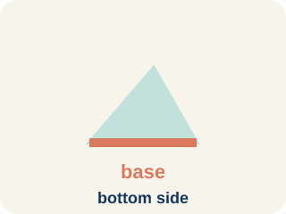
Base (Base) — A side of the triangle you use to find the area.
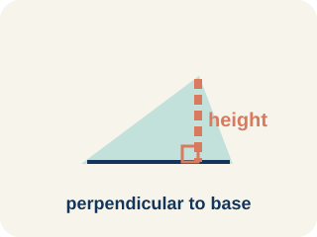
Height (Altura) — The straight-up distance from the base to the top corner.
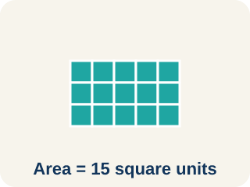
Area (Área) — How much space is inside a flat shape.
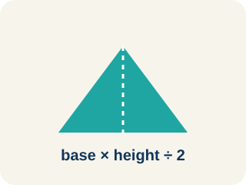
Perpendicular (Perpendicular) — Two lines that meet to make a square corner (90 degrees).
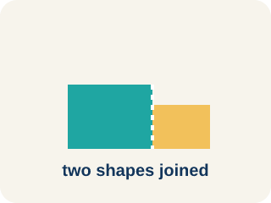
Composite figure (Figura compuesta) — A shape made by putting two or more simple shapes together.
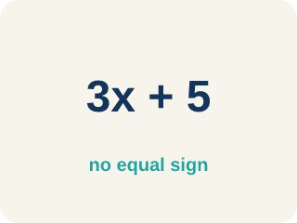
Formula (Fórmula) — A math rule written with symbols.

Practice
Show your work. Use the blank space under each problem.
1. What is the area of a triangle with base 10 cm and height 6 cm?
A. 30 sq cm
B. 60 sq cm
C. 16 sq cm
D. 30 cm
______________________________________________________________________
2. A triangle has an area of 24 sq ft and a base of 8 ft. What is the height?
A. 6 ft
B. 3 ft
C. 16 ft
D. 12 ft
______________________________________________________________________
3. Complete the table.
Triangle | Base | Height | Area
Garden A | 12 ft | 8 ft
Garden B | 9 ft |  | 27 sq ft
Garden C |  | 10 ft | 35 sq ft
Garden D | 15 ft | 4 ft
______________________________________________________________________
4. Match each shape to its area.
Item | Answer choices
____ Triangle b=8, h=6 | D. 21 sq units
____ Triangle b=10, h=8 | C. 30 sq units
____ Triangle b=12, h=5 | B. 40 sq units
____ Rectangle 7×3 | A. 24 sq units
______________________________________________________________________
5. Find Dana's Mistake
Step 1 (Problem): Find the area of a triangle with base 10 ft and height 7 ft.
Step 2 (Write the formula): A = ½ × b × h
Step 3 (Substitute): A = ½ × 10 × 7
Step 4 (Multiply): A = 10 × 7 = 70
Step 5 (Final answer): A = 70 sq ft
Which step has the mistake? Explain and fix it:
______________________________________________________________________
______________________________________________________________________
______________________________________________________________________
6. A triangular sail has an area of 30 sq m and a height of 12 m. What is its base?
A. 5 m
B. 2.5 m
C. 18 m
D. 360 m
______________________________________________________________________
7. What is the area of a triangle with base 16 m and height 5 m?
A. 40 sq m
B. 80 sq m
C. 21 sq m
D. 40 m
______________________________________________________________________
8. A triangle has an area of 36 sq cm and a height of 9 cm. What is its base?
A. 8 cm
B. 4 cm
C. 27 cm
D. 324 cm
______________________________________________________________________
9. Two triangles have the same area. One has a base of 12 ft and a height of 6 ft. The other has a base of 9 ft. What is the height of the second triangle?
A. 8 ft
B. 6 ft
C. 4 ft
D. 18 ft
______________________________________________________________________
10. You design a triangular roof gable for a client's cabin. The base measures 8 ft and the height measures 5 ft. What is the area of the gable?
A. 20 sq ft
B. 40 sq ft
C. 13 sq ft
D. 20 ft
______________________________________________________________________

Answer Key (Teacher)
1. A. 30 sq cm
A = ½ × b × h = ½ × 10 × 6 = 30 square centimeters.
Watch for: A common mistake in Area of Triangles is stopping after multiplying base × height and forgetting to take half — for example, computing 12 × 8 = 96 and writing 96 sq ft instead of 48 sq ft. Another common mistake is using a slanted side as the height instead of the perpendicular (straight-up) distance from the base. Before you submit, ask: Did I take half of base × height? Is my height measurement perpendicular to the base?
2. A. 6 ft
24 = ½ × 8 × h → 24 = 4h → h = 6 ft.
Watch for: A common mistake in Area of Triangles is stopping after multiplying base × height and forgetting to take half — for example, computing 12 × 8 = 96 and writing 96 sq ft instead of 48 sq ft. Another common mistake is using a slanted side as the height instead of the perpendicular (straight-up) distance from the base. Before you submit, ask: Did I take half of base × height? Is my height measurement perpendicular to the base?
3. Table
Garden A — Area: 48 sq ft
Garden B — Height: 6 ft
Garden C — Base: 7 ft
Garden D — Area: 30 sq ft

4. Matches:
Triangle b=8, h=6 → 24 sq units
Triangle b=10, h=8 → 40 sq units
Triangle b=12, h=5 → 30 sq units
Rectangle 7×3 → 21 sq units

5. Find Dana's Mistake
The mistake is in Step 4.
Correct work: Dana forgot the ½. The area is half of base × height: A = ½ × 10 × 7 = ½ × 70 = 35 square feet.
6. A. 5 m
30 = ½ × b × 12 → 30 = 6b → b = 5 m.
Watch for: A common mistake in Area of Triangles is stopping after multiplying base × height and forgetting to take half — for example, computing 12 × 8 = 96 and writing 96 sq ft instead of 48 sq ft. Another common mistake is using a slanted side as the height instead of the perpendicular (straight-up) distance from the base. Before you submit, ask: Did I take half of base × height? Is my height measurement perpendicular to the base?
7. A. 40 sq m
A = ½ × 16 × 5 = ½ × 80 = 40 square meters.
Watch for: A common mistake in Area of Triangles is stopping after multiplying base × height and forgetting to take half — for example, computing 12 × 8 = 96 and writing 96 sq ft instead of 48 sq ft. Another common mistake is using a slanted side as the height instead of the perpendicular (straight-up) distance from the base. Before you submit, ask: Did I take half of base × height? Is my height measurement perpendicular to the base?
8. A. 8 cm
36 = ½ × b × 9 → 36 = 4.5b → b = 8 cm.
Watch for: A common mistake in Area of Triangles is stopping after multiplying base × height and forgetting to take half — for example, computing 12 × 8 = 96 and writing 96 sq ft instead of 48 sq ft. Another common mistake is using a slanted side as the height instead of the perpendicular (straight-up) distance from the base. Before you submit, ask: Did I take half of base × height? Is my height measurement perpendicular to the base?
9. A. 8 ft
First area = ½ × 12 × 6 = 36 sq ft. Then 36 = ½ × 9 × h → 36 = 4.5h → h = 8 ft.
Watch for: A common mistake in Area of Triangles is stopping after multiplying base × height and forgetting to take half — for example, computing 12 × 8 = 96 and writing 96 sq ft instead of 48 sq ft. Another common mistake is using a slanted side as the height instead of the perpendicular (straight-up) distance from the base. Before you submit, ask: Did I take half of base × height? Is my height measurement perpendicular to the base?
10. A. 20 sq ft
A = ½ × b × h = ½ × 8 × 5 = ½ × 40 = 20 square feet.
Watch for: A common mistake in Area of Triangles is stopping after multiplying base × height and forgetting to take half — for example, computing 12 × 8 = 96 and writing 96 sq ft instead of 48 sq ft. Another common mistake is using a slanted side as the height instead of the perpendicular (straight-up) distance from the base. Before you submit, ask: Did I take half of base × height? Is my height measurement perpendicular to the base?

